**Hands on 1**

**Create a Spring Web Project using Maven**

package com.cognizant.spring_learn;

import org.springframework.boot.SpringApplication;

import org.springframework.boot.autoconfigure.SpringBootApplication;

import org.slf4j.Logger;

import org.slf4j.LoggerFactory;

@SpringBootApplication

public class SpringLearnApplication {

private static final Logger LOGGER = LoggerFactory.getLogger(SpringLearnApplication.class);

public static void main(String[] args) {

LOGGER.info("START");

SpringApplication.run(SpringLearnApplication.class, args);

LOGGER.info("END");

}

}

**OUTPUT:**

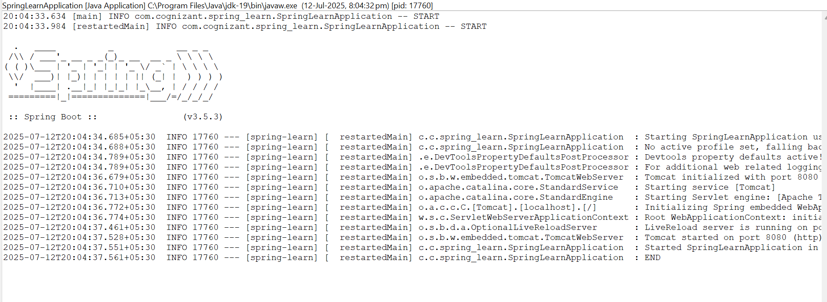

**Hands on 2**

**Spring Core – Load SimpleDateFormat from Spring Configuration XML**

package com.cognizant.spring_learn;

import java.text.ParseException;

import java.text.SimpleDateFormat;

import java.util.Date;

import org.slf4j.Logger;

import org.slf4j.LoggerFactory;

import org.springframework.context.ApplicationContext;

import org.springframework.context.support.ClassPathXmlApplicationContext;

public class SpringLearnApplication {

private static final Logger LOGGER = LoggerFactory.getLogger(SpringLearnApplication.class);

public static void main(String[] args) {

LOGGER.info("START");

SpringLearnApplication app = new SpringLearnApplication();

app.displayDate();

LOGGER.info("END");

}

public void displayDate() {

LOGGER.info("START");

ApplicationContext context = new ClassPathXmlApplicationContext("date-format.xml");

SimpleDateFormat format = context.getBean("dateFormat", SimpleDateFormat.class);

try {

Date date = format.parse("31/12/2018");

LOGGER.debug("Parsed Date: {}", date);

} catch (ParseException e) {

LOGGER.error("Error parsing date", e);

}

LOGGER.info("END");

}

}

**OUTPUT:**

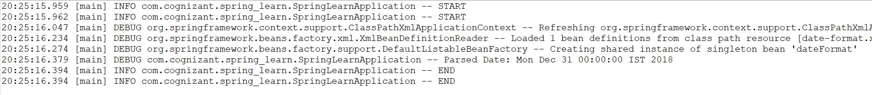

**Hello World RESTful Web Service**

package com.cognizant.spring_learn.controller;

import org.slf4j.Logger;

import org.slf4j.LoggerFactory;

import org.springframework.web.bind.annotation.GetMapping;

import org.springframework.web.bind.annotation.RestController;

@RestController

public class HelloController {

private static final Logger LOGGER = LoggerFactory.getLogger(HelloController.class);

@GetMapping("/hello")

public String sayHello() {

LOGGER.info("START");

LOGGER.info("END");

return "Hello World!!";

}

}

**OUTPUT:**

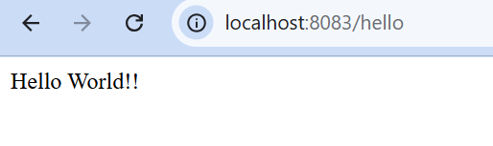

**REST - Country Web Service :**

package com.cognizant.spring_learn.controller;

import com.cognizant.spring_learn.Country;

import org.slf4j.Logger;

import org.slf4j.LoggerFactory;

import org.springframework.context.ApplicationContext;

import org.springframework.context.support.ClassPathXmlApplicationContext;

import org.springframework.web.bind.annotation.RequestMapping;

import org.springframework.web.bind.annotation.RestController;

@RestController

public class CountryController {

private static final Logger LOGGER = LoggerFactory.getLogger(CountryController.class);

@RequestMapping("/country")

public Country getCountryIndia() {

LOGGER.info("START");

ApplicationContext context = new ClassPathXmlApplicationContext("country.xml");

Country country = (Country) context.getBean("country", Country.class);

LOGGER.debug("Country: {}", country);

LOGGER.info("END");

return country;

}

}

**OUTPUT:**

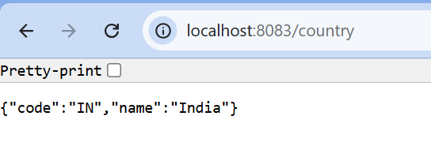

**REST - Get country based on country code :**

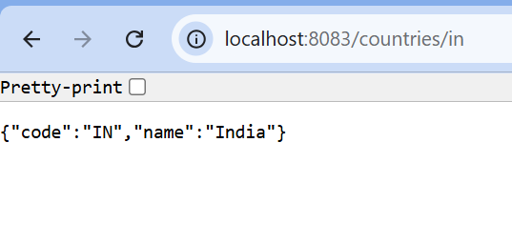

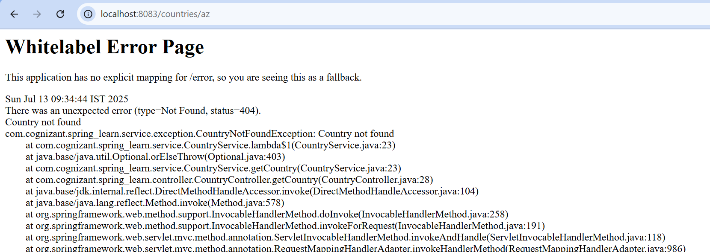

**Create authentication service that returns JWT**:

JwtUtil.java

package com.cognizant.spring_learn.util;

import io.jsonwebtoken.Jwts;

import io.jsonwebtoken.io.Encoders;

import io.jsonwebtoken.security.Keys;

import org.springframework.stereotype.Component;

import javax.crypto.SecretKey;

import java.util.Date;

@Component

public class JwtUtil {

private static final long EXPIRATION_TIME = 10 * 60 * 1000; // 10 minutes

private static final SecretKey key = Jwts.SIG.HS256.key().build();

public String generateToken(String username) {

return Jwts.builder()

.subject(username)

.issuedAt(new Date(System.currentTimeMillis()))

.expiration(new Date(System.currentTimeMillis() + EXPIRATION_TIME))

.signWith(key)

.compact();

}

public String getSecretKey() {

return Encoders.BASE64.encode(key.getEncoded());

}

}

AuthController.java

package com.cognizant.spring_learn.controller;

import com.cognizant.spring_learn.util.JwtUtil;

import org.springframework.beans.factory.annotation.Autowired;

import org.springframework.web.bind.annotation.GetMapping;

import org.springframework.web.bind.annotation.RestController;

import jakarta.servlet.http.HttpServletRequest;

import java.nio.charset.StandardCharsets;

import java.util.Base64;

import java.util.HashMap;

import java.util.Map;

@RestController

public class AuthController {

@Autowired

private JwtUtil jwtUtil;

@GetMapping("/authenticate")

public Map<String, String> authenticate(HttpServletRequest request) {

String authHeader = request.getHeader("Authorization");

if (authHeader == null || !authHeader.startsWith("Basic ")) {

throw new RuntimeException("Missing or invalid Authorization header");

}

String base64Credentials = authHeader.substring("Basic ".length());

byte[] decodedCreds = Base64.getDecoder().decode(base64Credentials);

String credentials = new String(decodedCreds, StandardCharsets.UTF_8);

String[] values = credentials.split(":", 2);

String username = values[0];

String password = values[1];

if (!("user".equals(username) && "pwd".equals(password))) {

throw new RuntimeException("Invalid credentials");

}

String token = jwtUtil.generateToken(username);

Map<String, String> response = new HashMap<>();

response.put("token", token);

return response;

}

}